**HORMISDALLEN SCHOOL - KYEBANDO**

**PRE-PLE SET 7 EXAMINATIONS, 2023**

**PRIMARY SEVEN SCIENCE**

Duration: 2 Hours 15 Minutes

**NAME: ____________________________________________STREAM: _________**

EMIS NO.

INDEX NO.

**SECTION A.**

1. Mention one example of an energy resource in the environment.

__________________________________________________________________________

1. Mention one disease spread by ticks to people.

__________________________________________________________________________

1. Which method can be used to find the volume of an Irish potato?

__________________________________________________________________________

1. How is ecdysis important to insects?

__________________________________________________________________________

1. Which part of the human eye is similar to the auditory nerves of the ear?

__________________________________________________________________________

1. Mention one part of the body where a gliding joint is found.

__________________________________________________________________________

1. Give one way in which the umbilical cord is useful to a baby in the womb.

__________________________________________________________________________

1. Why do farmers keep draught cattle?

__________________________________________________________________________

1. What happens when light moves from one transparent medium to another?

__________________________________________________________________________

1. Which type of soil is used in making glass?

__________________________________________________________________________

1. Mention one example of a soil pollutant.

__________________________________________________________________________

1. Which term is used to mean the act of exposing seedlings to the main garden conditions?

__________________________________________________________________________

1. State the structural difference between a **vein** and an **artery**.

____________________________________________________________________________________________________________________________________________________

1. Give the function of fungi in a food chain.

__________________________________________________________________________

1. Which deficiency disease is caused by lack of vitamin A in the diet?

__________________________________________________________________________

1. Which part of the tape worm absorbs food from the host?

__________________________________________________________________________

1. Mention the best way married people can protect themselves from contracting HIV/AIDS.

__________________________________________________________________________

1. Why does a fish die after being removed from water?

__________________________________________________________________________

1. How is recycling of wastes useful in the environment?

__________________________________________________________________________

1. What is the role of plants in the water cycle?

__________________________________________________________________________

1. Why is an eagle called a bird of prey?

__________________________________________________________________________

1. State one way of conserving non-renewable resources.

__________________________________________________________________________

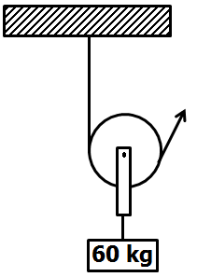**The diagram below is a pulley. Use it to answer questions 23 and 24.**

1. Name the type of pulley shown in the diagram above.

________________________________________________________________________________________________________

1. Calculate the effort needed to raise the load shown in the pulley above.
2. In which way is the function of the **gallbladder** different from that of the u**rinary bladder**? _____________________________________________________________________________________________________________________________________________________
3. How are tsetse flies dangerous to cattle?

__________________________________________________________________________

1. Why are windows placed at a lower level than ventilators?

__________________________________________________________________________

1. Give one way in which rusting affects metals.

__________________________________________________________________________

1. Why is disease control in free range system of poultry keeping difficult?

**________________________________________________________________**

1. In which way is a pouch important to a kangaroo?

__________________________________________________________________________

1. **Name the lens below.**

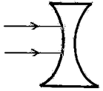

_________________________________________________

1. Complete the above diagram by showing the effect of the lens on a parallel beam of light.
2. Which eye defect is corrected by the above lens?

__________________________________________________________________________

1. State the mineral salt lost from the body due to diarrhoea.

__________________________________________________________________________

1. Write down one secondary sex change that occurs in both boys and girls during adolescence.

__________________________________________________________________________

1. Apart from mosses and ferns, give one other spore bearing non-flowering plant.

__________________________________________________________________________

1. **In the space below, draw the stamen and show the filament.**
2. How are treads useful in car tyres?

__________________________________________________________________________

1. Mention one method of extracting honey.

__________________________________________________________________________

1. Give one way in which sweating is useful to the body.

__________________________________________________________________________

**SECTION B (60 MARKS)**

1. a) State the difference between heat and temperature.

____________________________________________________________________________________________________________________________________________________

1. Give one reason why alcohol is used to measure minimum temperature.

__________________________________________________________________________

c) Convert 68o**F** to o**C.** (2 marks)

1. a) How do the following organisms move?
2. Amoeba: __________________________________________________________________
3. Bacteria: __________________________________________________________________
4. Write down one similarity between amoeba and bacteria.

____________________________________________________________________________________________________________________________________________________

1. Apart from causing diseases, state any one other danger of bacteria to people.

__________________________________________________________________________

1. a) What are arthropods?

____________________________________________________________________________________________________________________________________________________

1. Mention one example of each of the following groups of arthropods.
2. Crustacean: ________________________________________________________________
3. Myriapod: __________________________________________________________________
4. Arachnid: __________________________________________________________________
5. **Below are three bottles of the same size with different water levels.**

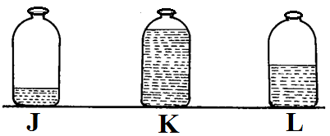

1. Which bottle will produce the lowest pitch?

__________________________________________________________________________

1. Give a reason for your answer in **44(a)** above.

____________________________________________________________________________________________________________________________________________________

1. How do the bottles above produce sound when blown?

____________________________________________________________________________________________________________________________________________________

1. Mention the method of storing sound shown below.

**d:r m : l r :- m - d : - : - : -**

__________________________________________________________________________

1. a) Name the enzyme that acts on un cooked starch in the duodenum.

__________________________________________________________________________

1. What is the role of enzymes during digestion?

__________________________________________________________________________

1. State any two characteristics of enzymes.
2. __________________________________________________________________________
3. __________________________________________________________________________
4. **Two loads are balancing on a sea saw as shown below.**

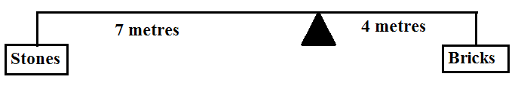

1. Which of the two loads above is heavier?

__________________________________________________________________________

1. Give a reason for your answer in **46(a)** above.

____________________________________________________________________________________________________________________________________________________

1. Why is a sea saw grouped under first class levers?

____________________________________________________________________________________________________________________________________________________

1. In which class of levers does a wheel barrow belong?

_________________________________________________________________

1. In four short sentences, explain how you can separate a mixture of salt and sand.
2. __________________________________________________________________________________________________________________________________________________
3. __________________________________________________________________________________________________________________________________________________
4. __________________________________________________________________________________________________________________________________________________
5. __________________________________________________________________________________________________________________________________________________
6. a) What happens to the volume and mass of water when frozen?
7. Volume: ___________________________________________________________________

__________________________________________________________________________

1. Mass: _____________________________________________________________________

__________________________________________________________________________

1. State any two effects of heat on matter.
2. __________________________________________________________________________
3. __________________________________________________________________________
4. 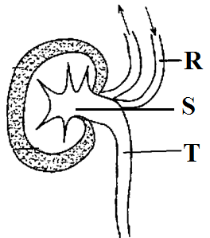**The diagram below shows the cross section of a kidney. Use it to answer questions that follow.**
5. Name the parts marked **R** and **S**.
   1. **R**: _____________________________________________________________________
   2. **S**: _____________________________________________________________________
6. Give the function of part marked **T**.

____________________________________________________________________________________________________________________________________________________

1. Use an arrow and letter **P** to show the part where selective reabsorption takes place.
2. a) State the main reason why farmers keep Angora breeds of goats.

____________________________________________________________________________________________________________________________________________________

1. Why do farmers prefer keeping exotic breeds of goats to local ones? Give two reasons.
2. __________________________________________________________________________
3. __________________________________________________________________________
4. Give one importance of feeding a pregnant goat on feeds rich in proteins.

____________________________________________________________________________________________________________________________________________________

1. a) What causes fainting?

__________________________________________________________________________

1. Give the first aid for fainting.

____________________________________________________________________________________________________________________________________________________

1. In which way is each of the following useful in first aid
2. Armsling? ____________________________________________________________________________________________________________________________________________________
3. Tourniquet? ___________________________________________________________________________________________________________________________________________________
4. **The diagram below shows an Irish potato tuber.**

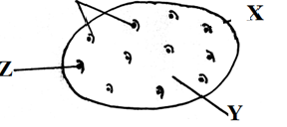

1. Name part **Z**.

__________________________________________________________________________

1. State the collective name for part **X** and **Z**.

__________________________________________________________________________

1. Give the function of part **Y**.

____________________________________________________________________________________________________________________________________________________

1. Why is the Irish potato called a stem tuber?

__________________________________________________________________________

1. a) Mention the two regions of the human skeleton.
2. __________________________________________________________________________
3. __________________________________________________________________________
4. Write down two ways in which ta P.7 pupil can keep his /her skeleton in a good working condition.
5. __________________________________________________________________________
6. __________________________________________________________________________
7. 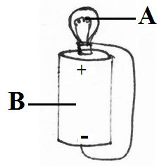**Below is a simple electric circuit. Use it to answer questions that follow.**
8. Name the part marked **A**.

__________________________________________________________________________

1. State the energy changes that occur in part marked **B**.

__________________________________________________________________________

1. Why is part **A** coiled?

__________________________________________________________________________

1. Use as arrow to show the direction of flow of electricity.
2. **Match the diseases in A to their respective caustic agents in list B.**

**A B**

1. Coccidiosis virus
2. Athletes foot bacteria
3. Fowl typhoid protozoa
4. Newcastle fungi
5. Coccidiosis: ___________________________________________________________
6. Athletes foot: ___________________________________________________________
7. Fowl typhoid: ___________________________________________________________
8. Newcastle: ___________________________________________________________

**\*\*\*\*Good luck\*\*\*\***